DATE: 09-10-2026
DAY 1 – LINUX COMMANDS

Linux File System Explorer:
1. What is the purpose of /etc?
The /etc directory stores system-wide configuration files.
- Contains settings for the operating system and applications.
- Used to configure services, networking, users, and other system components.
- Usually contains text-based configuration files.
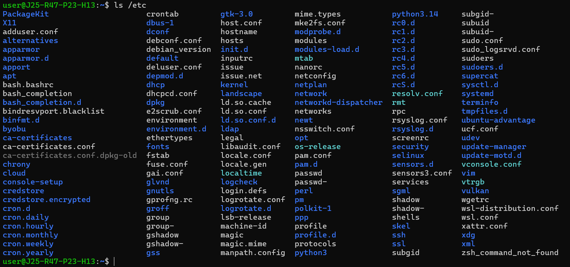
Examples:
- /etc/passwd – user account information. (cat /etc/passwd)
- /etc/hosts – maps hostnames to IP addresses.
- /etc/ssh/sshd_config – SSH server configuration.
2. What is /var used for?
The /var directory stores variable data that changes frequently while the system runs.
- Contains logs, caches, and application data.
- Stores information that grows or changes over time.
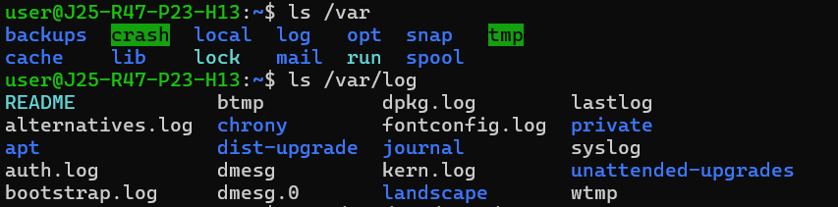
Examples:
- /var/log/ – system and application log files.
- /var/cache/ – cached application data.
- /var/tmp/ – temporary files that are generally preserved longer than files in /tmp.
3. What is /home used for?
The /home directory stores personal directories and files belonging to regular users.
- Each user generally has a separate home directory.
- Users store documents, downloads, projects, and personal settings here.
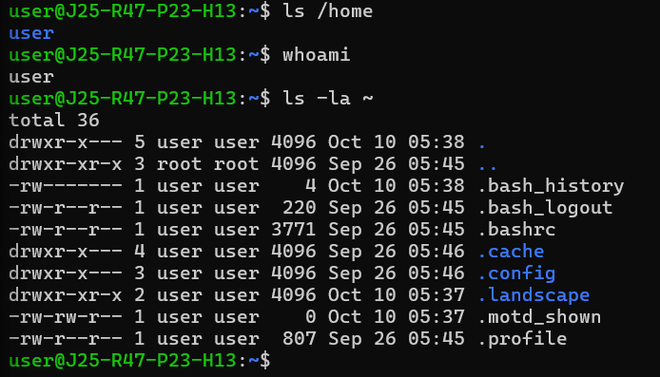
Examples:
- /home/harini/ – the home directory for a user named harini.
- /home/harini/Documents/ – the user's documents.
4. What is /tmp used for?
The /tmp directory stores temporary files created by applications and users.
- Used for temporary processing, intermediate files, and short-lived data.
- Files may be deleted automatically during system cleanup or reboot, depending on the system configuration.
- It should not be used to store important files permanently.
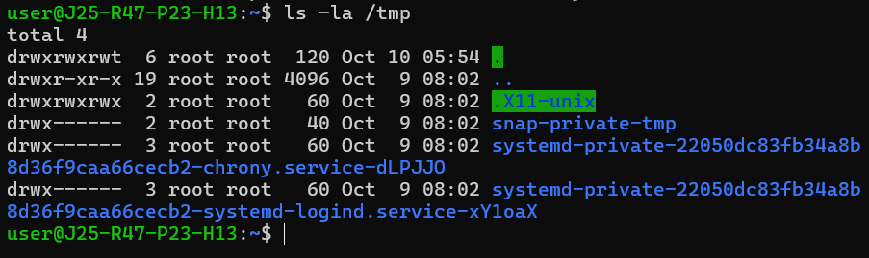
Example: An application might create a temporary file in /tmp while processing a document.
5. What is /usr used for?
The /usr directory contains many user-space programs, libraries, documentation, and other shared resources.
Despite its name, it is not simply a directory for personal user files.
Examples:
- /usr/bin/ – many commonly used commands and programs.
- /usr/lib/ – libraries needed by programs.
- /usr/share/ – architecture-independent data, such as documentation.
- /usr/local/ – software and files installed locally by the administrator.

Challenge question:
If an application is generating log files, which Linux directory would you normally investigate first, and why?
Answer: I would check /var/log first because it normally stores system and application log files that help identify errors and troubleshoot problems.
Command: ls /var/log
Linux Commands Investigation
1. What does pwd do?
The pwd command stands for Print Working Directory. It displays the full path of the directory you are currently working in.
It helps you identify your current location in the Linux file system.
This means your current working directory is /home/user.
When is it useful?
- To check your current location in the file system.
- To confirm which directory you are working in before creating or deleting files.
- To avoid accidentally running commands in the wrong directory.
2. What is the difference between ls and ls -la?
The ls command lists files and directories, while ls -la displays all entries, including hidden files, with detailed information.
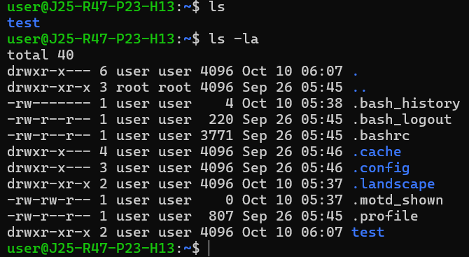
Examples:
ls
Lists non-hidden files and directories.
ls -la
Lists all entries, including hidden files, along with details such as permissions, ownership, size, and modification time.
Understanding the options:
- -l – Displays files in long format with detailed information.
- -a – Shows all entries, including hidden files beginning with a dot (.).
When is it useful?
- Use ls when you need a quick list of files.
- Use ls -la when investigating hidden files, permissions, ownership, or file details.
3. What does cd do?
The cd command stands for Change Directory. It allows you to move from your current directory to another directory in the Linux file system.
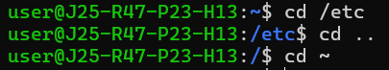
Examples:
cd /etc
Moves into the /etc directory.
cd ..
Moves one directory level up.
cd ~
Returns to your home directory.
When is it useful?
- To navigate between directories.
- To access files in a specific location.
- To enter a project directory before running commands.
Important: cd changes your current location; it does not create, delete, or modify files.
4. What does mkdir do?
The mkdir command stands for Make Directory. It creates a new directory in the specified location.
Examples:
mkdir myfolder
Creates a directory named myfolder in the current directory.
mkdir -p project/src/main
Creates the directory structure, including any missing parent directories.
Understanding the option:
- -p – Creates parent directories as needed and avoids an error if the directory already exists.
When is it useful?
- To organize files into folders.
- To create directories for software projects.
- To create a directory structure for source code, logs, or configuration files.
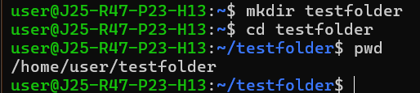
5. What does rm do?
The rm command stands for Remove. It deletes files and, when used with appropriate options, can also delete directories and their contents.
Examples:
rm file.txt
Removes a file named file.txt.
rm -r myfolder
Removes a directory and its contents recursively.
rm -i file.txt
Prompts for confirmation before removing the file.
Understanding the options:
- -r – Removes directories and their contents recursively.
- -f – Forces removal without many prompts and ignores nonexistent files.
- -i – Asks for confirmation before each removal.
When is it useful?
- To remove unwanted files.
- To clean up temporary files.
- To remove test directories after completing an exercise.

Challenge question:
What happens if I execute rm -rf?
The rm -rf command recursively deletes files and directories without many confirmation prompts.
- rm – Removes files.
- -r – Recursively removes directories and their contents.
- -f – Forces removal and ignores many errors and prompts.
Why is this command dangerous?
- It can permanently delete important files and directories.
- It usually does not ask for confirmation.
- Using an incorrect path can cause accidental data loss.
- Running it with sudo can put critical system files at risk.

Linux Permissions
1. What does rwx mean?
In Linux, rwx represents three types of file permissions:
- r (Read): Allows a user to read the contents of a file.
- w (Write): Allows a user to modify a file.
- x (Execute): Allows a user to execute a file as a program or script.
For directories, read allows listing entries, write allows creating or removing entries (subject to other restrictions), and execute allows accessing items inside the directory.
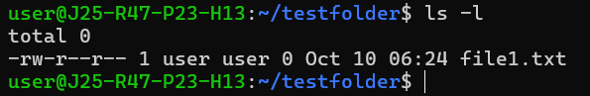This displays the permissions assigned to the file's owner, group, and others.
2. What are owner, group, and others?
Linux assigns permissions to three categories:
- Owner: The user who owns the file.
- Group: Users who belong to the file's associated group.
- Others: All other users.
For example, in -rwxr-xr--:
- Owner: rwx — read, write, execute.
- Group: r-x — read and execute.
- Others: r-- — read only.
3. What does chmod 755 mean?
The chmod command changes file or directory permissions. The number 755 represents permissions for the owner, group, and others.
- Owner: 7 = read + write + execute.
- Group: 5 = read + execute.
- Others: 5 = read + execute.
The numbers represent r = 4, w = 2, and x = 1.
Example:
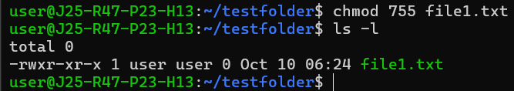This gives the owner full permissions and allows group members and others to read and execute the script.
4. What does chmod 644 mean?
The 644 permission gives the owner read and write access, while group members and others receive read-only access.
- Owner: 6 = read + write.
- Group: 4 = read only.
- Others: 4 = read only.
Example:
chmod 644 notes.txt
This is commonly used for regular text files that do not need to be executed.
5. Why is chmod 777 generally discouraged?
The 777 permission gives everyone read, write, and execute permissions.
- Owner: rwx
- Group: rwx
- Others: rwx
Example:
chmod 777 file.txt
It is discouraged because any user with access to the file may be able to modify or execute it. This can create security risks, including unauthorized changes and malicious code execution.
Challenge:
Is chmod 777 always required when a user gets "Permission denied"?
No. The error may be caused by incorrect ownership, missing permissions, directory access restrictions, or other security controls.
Instead of using chmod 777, investigate the permissions and ownership first.
Useful commands:
ls -l file.txt
id
namei -l /path/to/file
These help you inspect file permissions, your user and group memberships, and permissions along the directory path.
Conclusion: Always grant only the permissions required. Using chmod 777 as a quick fix can expose files and applications to unnecessary security risks.

Linux Processes
1. What is a Linux process?
A Linux process is an instance of a program that is currently running. Each process has a unique Process ID (PID), which helps the operating system identify and manage it.
Examples include a running web server, a browser, or a Python script.
Commands:
ps
Displays processes associated with the current terminal.
echo $$
Displays the process ID of your current shell.
2. What does ps show?
The ps command stands for Process Status. It displays a snapshot of currently running processes.
It typically shows:
- PID – Process ID.
- TTY – Associated terminal.
- TIME – CPU time used.
- CMD – Command that started the process.
Command:ps
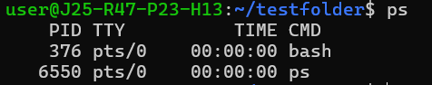
When is it useful? To check which processes are running in your current terminal session.
3. What does ps aux show?
The ps aux command displays a detailed snapshot of processes across the system, including processes running under other users.
It shows:
- USER – User running the process.
- PID – Process ID.
- %CPU – CPU usage.
- %MEM – Memory usage.
- STAT – Process state.
- COMMAND – Command used to start the process.
Command:ps aux
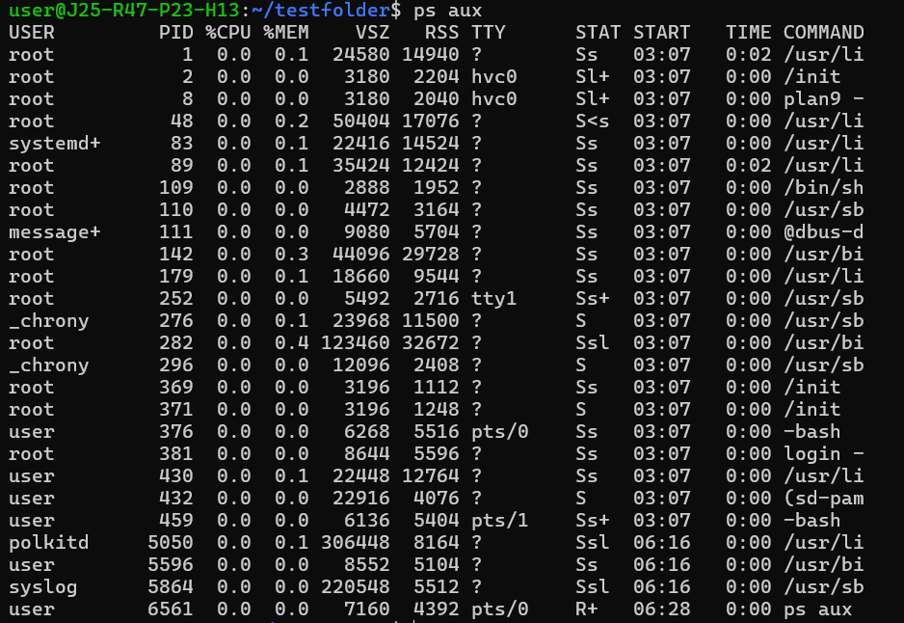
When is it useful? To investigate which applications are running and identify processes consuming significant CPU or memory.
4. What does top do?
The top command displays a continuously updating view of running processes and system resource usage.
It provides information about:
- CPU utilization.
- Memory and swap usage.
- Process IDs and users.
- CPU and memory consumption per process.
- Process states and running time.
Command: top
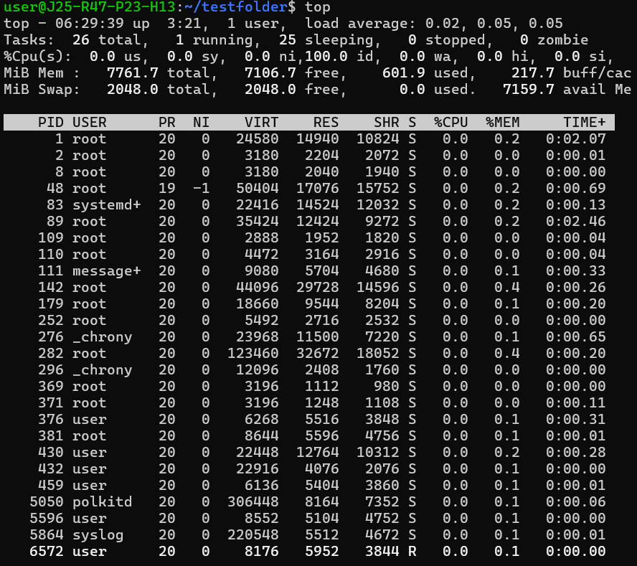
Press q to exit.
When is it useful? To monitor system performance in real time and identify processes that may be consuming excessive resources.
5. Why would a developer investigate processes?
Developers investigate processes to troubleshoot application and system problems.
Common reasons include:
- Identifying applications consuming too much CPU or memory.
- Finding stuck or unresponsive processes.
- Checking whether an application is running.
- Investigating performance problems.
- Identifying unexpected processes.
Useful commands:
ps aux
top
pgrep -a java
The last command searches for processes whose command names match java.
Challenge: If an application is running slowly, can top help investigate the problem?
Yes. The top command can help identify whether an application is consuming excessive CPU or memory.
For example, a developer can inspect the process's PID, CPU usage, memory usage, and state to identify possible resource bottlenecks.
However, top does not automatically identify the root cause of the slowdown. Further investigation using application logs, disk and network diagnostics, or application-specific tools may be necessary.

